Research:

**10. Blade Runner**

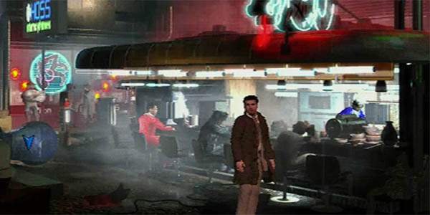The Blade Runner game was not a remake of the film but a new story set within the same universe. It ran as a side story to it and even had a few side characters that popped up. The game came out fifteen years after the initial cult classic, allowing fans to revisit famous locations and enjoy references to the main plot. It featured great looking set pieces that fit beautifully with the Blade Runner theme. As with most great point and click adventures, the voice acting was mostly very good with only the games minor characters having the cringeworthy bad acting. It also boasted decent graphics for a game that was released in 1997 with well done music that acted as a tribute to the score of the movie since permission could not be obtained to use the original soundtrack. Blade Runner initially claimed to be a "Real Time" adventure and though it did feature NPC characters with their own agenda, time didn't really affect anything that happened in the game. What did affect the game though was your key decisions and gameplay style. As you moved around the game exploring and making choices, so did the rest of the games characters. This opened up a new strategy, as you had to be quite careful how to act and when to carry out certain actions. The decisions you make (or failed to make) resulted in multiple branching storylines that let the game had an incredible 13 different endings. Impressive for a game of its time. Repeated playing of the game meant that different characters would be "Replicants," the enemies you were trying to expose in the story. The wealth of variety meant that you did end up with a few contradictions and loose ends, but these were easy to look past and didn't affect enjoyment of the game. For hardcore Blade Runner fans, the fact that it was a side story to the movie was probably reason enough to play. Add to that the fact that you also got to take control of the tools of the trade like the "Voight Kampff" device and you have a quality experience for fans. For non Blade Runner fans, there was still a solid adventure game to be found meaning being a fan was non-essential to enjoying playing. Although it didn't have as many puzzles as some of its brethren it was a high quality police investigation style adventure game.

**9. Myst**

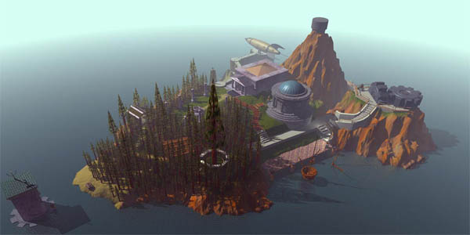Myst is one of those games that sometimes gets a bad reputation, probably because of the insane amount of games it inspired. Though it hasn't aged very well and has been long overtaken by other games in the genre, it deserves a mention for the sheer influence it has had over the years. A quick trip to any website offering Flash Games is the only evidence you need to see Myst type room escape games by the dozen. At one time, Myst was the best selling PC game ever and thus has received numerous remakes over the years. It was a surprisingly successful game in its day despite being a very niche genre that wasn't for everyone. While other point and click games featured dialogue and obvious story to push the game forward, Myst had nothing of the sort. You found yourself on a strange island and basically had to click your way around finding and solving problems until you started to feel some sort of progress. Understandably, this very vague approach to what you had to do meant that while a lot of people played Myst, very few stuck with it long enough to find out what happens. Most obviously the environments looked great as you explored the MYSTerious island figuring out exactly what was going on. The lack of dialogue coupled with the lack of inventory and instructions meant for a very immersive experience. Your screen wasn't burdened with options and menus, instead letting the whole island take up your view. It was just you and your mouse icon tackling mazes, puzzles and problems in an attempt to unravel the MYSTery. A notoriously difficult game to figure out, most gave up in frustration before getting very far and to be honest, the ending itself was a letdown when you finally got there. Nevertheless Myst has had its fair share of sequels over the years, with this original version seeing numerous remakes including its latest for the 3DS. Admittedly, it hasn't held up too well and new audiences who haven't played it before would no doubt wonder how we ever put up with it, perhaps an indication just how far the genre has come since 1993. To be fair though, Myst at the time was an original, immersive, somewhat groundbreaking adventure that brought the genre to a much wider audience.

**8. Maniac Mansion**

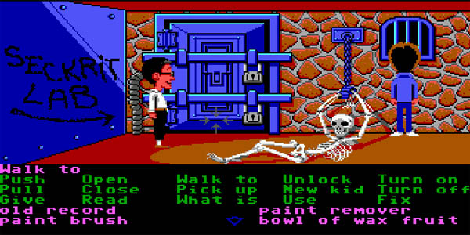It cannot be understated just how much Lucasarts did for adventure games with the implementation of their Script Creation Utility for Manic Mansion (or SCUMM.) SCUMM took all of the guess work out of point and click games. Whereas previously you had to not only find the right item, you had to tell the game the right action to take with it. With SCUMM, the game gave you the options and you just had to find the right ones. Released in 1987, Maniac Mansion was one of the first games to show off how good SCUMM could be. It was first released for Commodore 64 and eventually ported to numerous other places, including a heavily edited NES version that took some things out to fit with Nintendo policy at the time. Dave's girlfriend has been kidnapped and locked in a mansion and you must switch between he and his partners using their unique skills to solve puzzles to progress and eventually save the girl. Some may have been turned off by the basic story but the puzzles more than made up for it. They were expertly put together and your game progression affected which ending you would eventually get. Frustratingly you could also get into a scenario where a bad choice or forgetting something would leave you at a dead end and having to restart. What stood out most was its sense of humour, which was darkly comic, taking aim at B Movie Cliches and featuring some genuinely funny moments. The new engine revolutionized how point and click games were played with the ease of its interface and a cinematic presentation that wasn't widely seen at the time. It spawned another successful sequel, Day of the Tentacle which was another fantastic game. Most importantly it set the stage for what could be done in the genre once even more tweaks were made to the SCUMM system.

**7. Syberia**

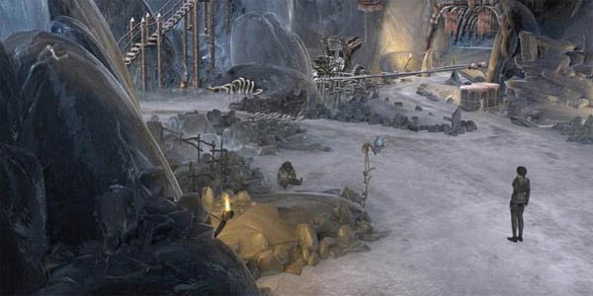Fast forward to 2002 and the adventure game was still going strong. Syberia showed just how far the genre had come since Maniac Mansion while still harkening back to the style established by those earlier titles. Syberia made use of the technology of the time to create a sometimes beautiful 3D world. These great graphics, its inventive setting and a highly engrossing story made it a great addition to the already impressive list of adventure games. For those unfamiliar, you take control of Kate, an associate lawyer who is trying to secure a major business deal to acquire a toy company. Sounds boring, right? Well luckily her quest takes her all over a somewhat steampunk Europe made up of static but great looking backgrounds with fully animated characters inhabiting them. It made use of a context sensitive clicking system with the cursor changing to let you know how each hot spot could be interacted with. This and the games inventory were very easy to use making everything all the more enjoyable. One of the games most impressive features was the dialogue, with it being written intelligently and grown up rather than the usual comedy that point and click games favoured for the most part. It was a fresh approach and the quality of the voice acting in its main characters only served to showcase how well written the game was. Some side characters were the usual fun of the mill type, but it's to be expected with most games. The story came across as slightly deeper than most point and clicks, particularly in the fleshing out of Kate's back story which was told through her personal phone calls to her friends and family back home. Syberia was deliberately slow paced and really allowed you take everything in. Added to that, the puzzles were never over the top frustratingly tough and usually very believably related to the story unfolding rather than just included for the sake of having a puzzle. Two years later, it got the sequel it deserved and in August of this year a third installment finally went into production for a 2014/15 release. Plenty of time to play through the first two in time for that.

**6. Secret Of Monkey Island**

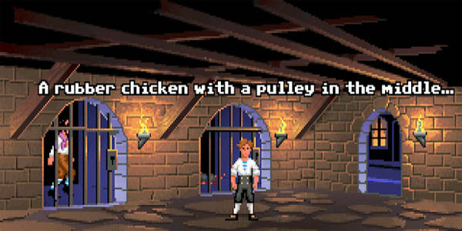Another Lucas Arts classic. While Maniac Mansion was the first to set out the stall for the Golden Generation of adventure games, Secret of Monkey Island was probably the first one to get almost everything perfect. Taking what had been accomplished in Maniac Mansion, use of the SCUMM engine was streamlined further and modified to put the emphasis on puzzle solving and exploring. While Maniac Mansion was a great game, some of the puzzle solving was admittedly frustrating and the ability to paint yourself into a corner was never a good thing. These few flaws were addressed in Monkey Island, making for a massively more enjoyable experience on the whole. It was one of the first games to feature a dialogue tree for talking choices and was designed so that you never came to a dead end. The setting of the weird and wonderful Monkey Island was a great choice allowing for all kinds of comedy scenarios for the games now famous protagonist Guybrush Threepwood to get into. This sense of humor undoubtedly set it apart but it was also aided by great visuals, brilliant audiovisuals and most importantly fantastic gameplay. It spawned an equally great sequel soon after, and eventually a total of 5 graphical adventure games with now leaders of the genre Telltale Games getting involved for the fifth in the series. A 2009 remake for Xbox 360 and other consoles was well received with even better music, hand drawn graphics, quality voice work and a hint option for those who weren't suited to point and click games. The new graphics in particular made it much easier for current audiences to get used to. Either way, Secret of Monkey Island is easily one of the best point and click games available and well worth a visit if the recent Telltale games have made you a fan of the genre.

**5. Grim Fandango**

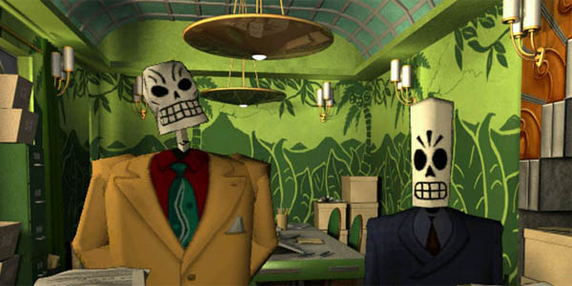Sticking with Lucas Arts again, we move onto the hugely popular Grim Fandango. It was a close call between it and Sam & Max, but Grim got the nod due to the originality of its setting. Written by the now veteran Tim Schafer who brought a dark comedy approach to the style of the game. In a new move for Lucas Arts games, it became the first of theirs to use 3D graphics on static backgrounds. Again, all the staples of the genre were present. Great humour and writing, brilliant game design and clever puzzles. Fandango benefitted from being able to take all the best bits from the previous Lucas Arts titles and put them together to make one of the best point and click games ever. You control Manny, an employee of the Department of Death who finds Travel Packages for incoming souls and helps them get to their final reward. The game follows his being tasked with selling a Premium package or be faced with losing his job. The puzzles you face are sometimes big and complex but at no point overwhelming. Fandango is a lesson in design work, with a unique game world and a wide variety of places to travel and an art style highly influenced by the Day of the Dead parade in Mexico. Some consider Grim Fandango the best of the Lucas Arts series of adventure games and while that is debatable it is definitely up there with the greatest.

**4. Beneath A Steel Sky**

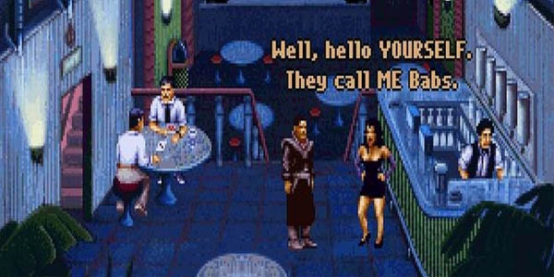Though we could probably make a list completely made up of Lucas Arts games, it's only fair we delve into a few different games as there are plenty other great ones out there. One such game is Beneath a Steel Sky, another point and click game set in a cyberpunk world where most live in tight city surroundings while the rest of the world is a Mad Max style wasteland. In stark contrast to most other adventure games it stands out by being a particularly bleak story and setting though it also has very solid gameplay to back it up. It might sound like the title of a U2 song, it just isn't as bleak as listening to them. To break up the bleakness, Revolution Software included some trademark humor, particularly with your robotic sidekick who tags along for the journey. Again, the voice acting makes all the difference and brings a certain believability to the characters and world. Like Blade Runner it attempts a somewhat real time approach in its "Virtual Theatre" scripting system meaning that characters have their own agendas and wander around the game world doing their own thing. Unlike Blade Runner though it is a lot more linear and nothing the like of that games numerous endings. Though you can die in the game, these moments are presented as logical puzzles and not dead end situations where you have to restart the game. Interactions come with a very simple right and left click system as opposed to the SCUMM style text box at the bottom of the screen, allowing for a lot more room for its highly detailed world map. Beneath a Steel Sky was remastered for a new audience in 2009 and remained a popular game with the new additions only serving to emphasize how good the game always was. Revolution recently said that a sequel would be made if their Broken Sword Kickstarter made it to a goal of 1 million. Despite not reaching that magic number the success that they DID manage encouraged them to begin work on a sequel which will resume after the release of Broken Sword 5 in December. Anyone interested in playing the original before the sequel comes might be happy to know that it is currently available to download for free on GOG.com.

**3. The Last Express**

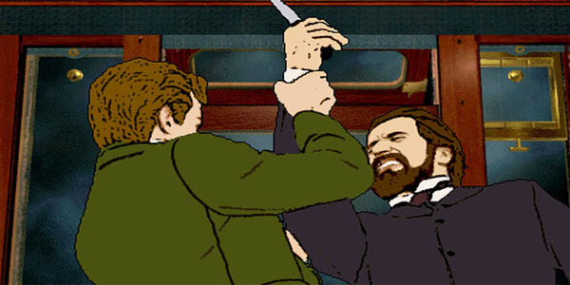The Last Express is set on the famous Orient Express just before the outbreak of World War One. You play as an American doctor on the run who gets involved with everyone else's problems on the train as well as his own. On his long journey, Robert Cath must do his best to stay alive while interacting with 30 very different characters each with their own unique back story and place in the script. It is extremely non linear with every action (or non action) affecting which way the story progresses. Because of the sheer amount of ways the story can twist, the script for the game was said to be 800 pages long. Of the numerous endings, only four are considered "non fatal" endings where Cath escapes alive or without being arrested. Of these, only ONE is considered the "right" ending while also featuring dozens of "bad" endings where you die or are captured. Akin to Blade Runner, the other NPCs move about the game at their own will, even changing their own plans based on how the player plays the game. Despite Blade Runner's claims, The Last Express ACTUALLY had events that occurred in real time albeit at an accelerated pace that in all takes in 3 days of the train journey. At one point in the game, other characters put on a musical performance which takes up 20 minutes in real time and gives the player the option of sitting and watching or carrying out some business as it happens. The art style was very unique, using an extensive capturing process to give it a look unlike most games of the time. Though not a commercial hit it was widely loved by critics and by die-hard fans of the genre. The somewhat failure was in some ways due to its promotional companies shutting down and another closure putting an end to a planned Playstation port of the game. Again, a new version came out in 2012 and just last week a new "Gold" edition was finally released on Steam with new gameplay improvements and the usual Steam add-ons to boost its status as an already great game.

**2. Discworld**

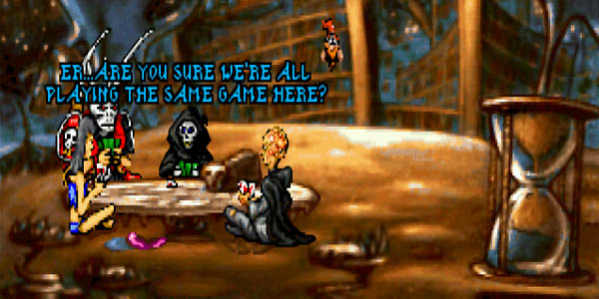Adapting anything from Terry Pratchett's Discworld was always going to be a daunting task. Using the genre of point and click to do so turned out to be a fitting way to honor the series. This style allowed the game to feature the trademark humor of the books along with great graphics to bring the extensive world to life. Impressively the main character is voiced by Eric Idle along with backup from other great sources including Rob Brydon and Baldrick himself, Tony Robinson. Like most point and click adventures it featured the usual item collecting, conversations and puzzle solving only this time within the madcap, hugely popular world of Terry Pratchett's books. Discworld proved to be a particularly difficult entry into adventure gaming history. It didn't have as smooth a system as some of the other games on the list and at sometimes felt a bit clunky. Additionally some of the items needed were ridiculously small within the world map, making some puzzles a frustrating experience. It also included a fair bit of trekking back and forth between the same areas. For those with the patience to brave that and the difficulty though, it is a rewarding experience especially for those who are die-hard fans of Pratchett's work already. Though not the complete package, its humor alone was almost enough to keep playing.

**1. Broken Sword**

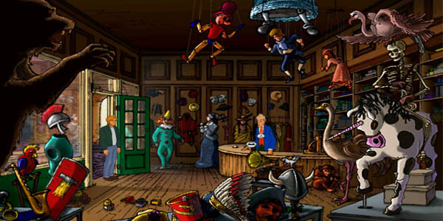Broken Sword is another Revolution Software game which came after Beneath a Steel Sky and featured a completely different gaming style. Instead of the darker approach taken in Steel Sky, Broken Sword mostly takes place in very bright, colourful locales with a somewhat more upbeat approach to its humour to go along with its mostly serious storyline. Perhaps due to looking almost like an animated Disney movie, Broken Sword is arguably one of the most famous point and click adventures that has been made. And rightly so. Its story, puzzles, voice acting, graphics and music were all brilliant, leading it to gain numerous ports over the years. Playing as American tourist George Stobbart (with help from Parisian journalist Nico Collard) it is a truly epic story spanning from an explosion in Paris all the way across the globe unraveling a Templar conspiracy with some tomb raiding and murder mystery along the way. Broken Sword took everything that games like Monkey Island did before it but expanded on them and did it all on an even larger scale. Not incredibly difficult but certainly not easy, Broken Sword is quite an accessible game and one of those with a story good enough to be a movie in its own right. In recent years a "Directors Cut" came out for Nintendo consoles and mobile devices that fleshed out the story even more and added new puzzles to the original. It was a huge commercial success and spawned a sequel (Smoking Mirror) that was almost as good as the first but didn't quite capture the magic. "The Sleeping Dragon" was a third installment in which the game moved into 3D territory for the first time in a move that turned off a lot of people. However, like Syberia it was still a very good point and click game that brought the genre firmly into the more modern era, even if it did have the most over the top ending of the three. The fourth game was another fair installment in the series though the original still could not be touched in terms of sheer quality across the board. For the upcoming 5th entry, Revolution have returned to the 2D style that helped make the first game so popular. As evidenced by the success of the Kickstarter campaign, fans are confident that this new installment can be just as good as the 4 that preceded it. Whether it can outdo the first game is unlikely but Revolution have proved over the years that they, like Lucas Arts, have a knack for making fantastic point and click games. "The Serpents Curse" comes out on December 4th and will hopefully add to the recent rejuvenation of interest in adventure games.